Ideation Phase
Define the Problem Statements

Date | 29 September 2026
Team ID | 6ab3d2b20fc666a751b3505e
Project Name | AI BlogNest API
Maximum Marks | 2 Marks

Customer Problem Statement Template:
Customer: Bloggers, content creators, developers, students, and businesses who need to create and manage blog content efficiently.
Problem: Customers often spend a lot of time researching topics, generating ideas, writing blog content, and managing their posts. Creating high-quality and engaging content manually can be time-consuming and difficult, especially when users need fresh content regularly.
Customer Need: Customers need a simple and efficient platform that can help them generate blog ideas, create content using AI, and manage blog posts through an easy-to-use API.
Problem Statement:
Bloggers and content creators need a faster and easier way to generate and manage high-quality blog content because researching topics and writing content manually can be time-consuming. AI BlogNest API provides AI-powered content generation and blog management features through an easy-to-use API, helping users create engaging blog content more efficiently.
Build with the OpenAI API 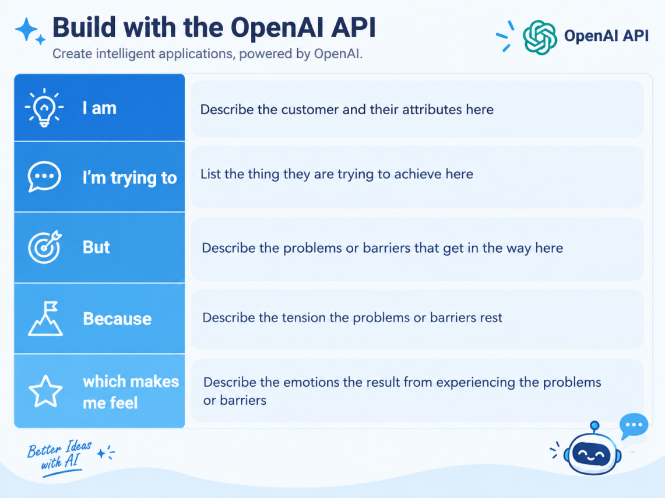

Example:
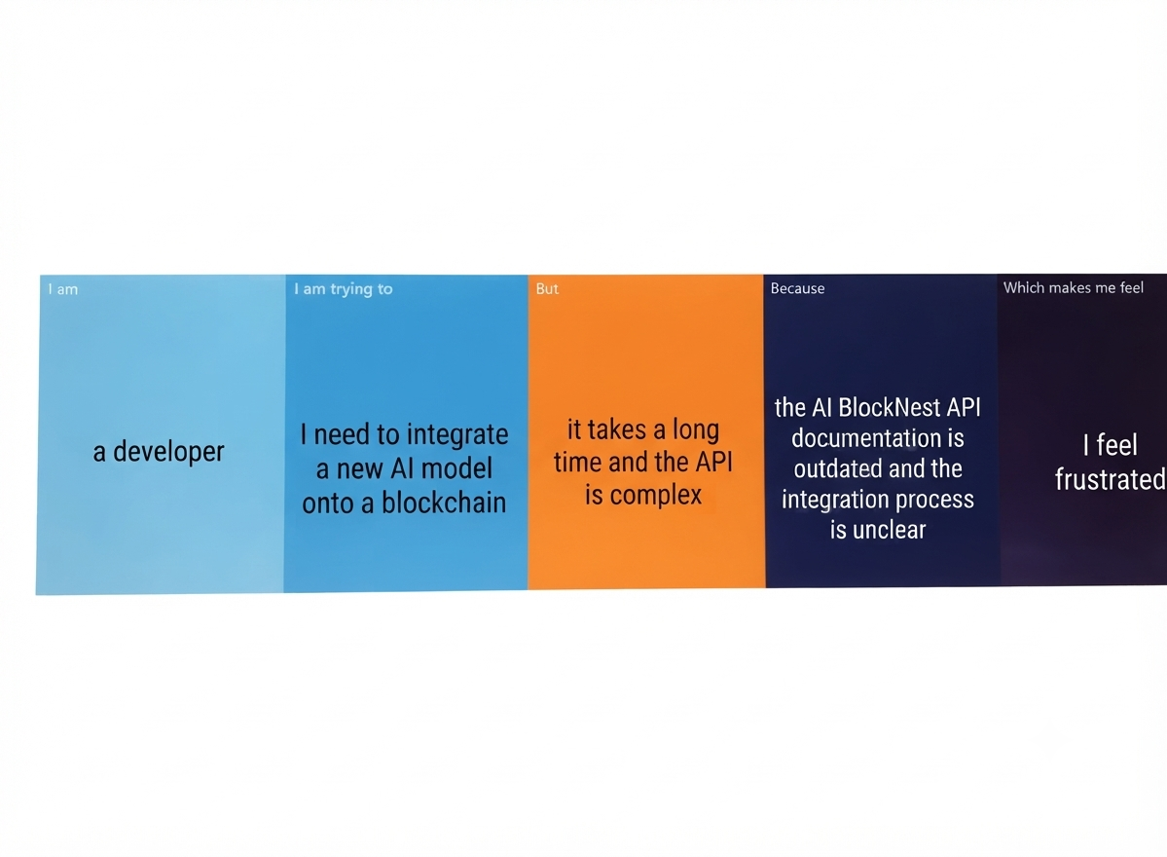

Problem Statement (PS) | I am (Customer) | I’m trying to | But | Because | Which makes me feel
PS-1
PS-2

